Chip back potential is the level which bulk silicon is maintained by on-chip connection, or it is the level to which the chip back must be connected when specifically stated below. If no potential is given the chip back should be isolated.
.129”
PAD FUNCTIONS:

- V _{IN} (2 bond pads)
- V _{OUT} (2 bond pads)
- V _{OUT} SENSE
- ADJUST

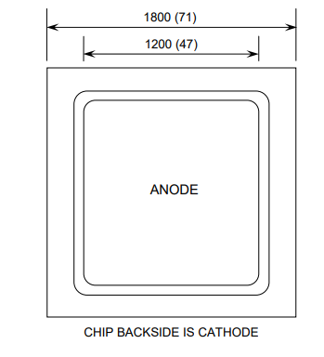

Top Material: Al
Backside Material: Ti/Ni/Ag
Bond Pad Size: .095 X .095” min.
Backside Potential: Cathode
Mask Ref:

APPROVED BY: KW DIE SIZE .118 X .118” DATE: 1/18/23
MFG: Silicon Supplies THICKNESS: .087” P/N: MURC1560
DG 10.1.2

Rev B, 7/19/02

